Optimizing Agriculture Using Machine Learning Techniques

Abstract
This project focuses on developing an integrated system for agricultural optimization, including soil prediction, crop recommendation, plant disease detection, fertilizer suggestion, and crop yield prediction. The goal is to assist farmers in making informed decisions to improve agricultural productivity and sustainability through data-driven insights. The system leverages advanced machine learning and deep learning techniques to provide comprehensive support across various aspects of farming. The system begins by analyzing soil images to classify the soil type using a Convolutional Neural Network (CNN) model. Based on the identified soil type, it recommends suitable crops using Random Forest and XGBoost algorithms. The system also includes a plant disease detection module using a CNN model based on the MobileNet architecture. Farmers can upload leaf images, and the model identifies common diseases like blight, rust, and leaf spot. Early detection allows timely intervention, reducing crop loss and improving produce quality. For each disease, the system provides management strategies to prevent further spread. Fertilizer recommendations are made using Random Forest and XGBoost based on plant disease. Finally, the project employs LSTM to predict crop yield by considering various location, name of the area and soil parameters. This integrated approach assists farmers in making informed decisions for optimal crop selection, disease management, and maximizing agricultural productivity. Overall, the project demonstrates the potential of AI-driven solutions to address complex challenges in agriculture and contribute to global food security efforts. The project hi fdu1 ghlights AI's potential in tackling agricultural challenges, supporting sustainable farming practices, optimizing resources, and boosting productivity, for global food security.
Keywords – Soil analysis, Crop yield prediction, plant disease identification, CNN, Random Forest, XGBoost, and LSTM.

- Introduction
Agriculture is a critical sector that sustains global food security, yet it faces numerous challenges including unpredictable climate conditions, soil degradation, plant diseases, and suboptimal resource management. To address these issues, advancements in artificial intelligence (AI) and machine learning (ML) offer innovative solutions for optimizing agricultural practices. This project introduces an integrated system aimed at revolutionizing traditional farming by providing data-driven insights for soil analysis, crop recommendation, plant disease detection, fertilizer suggestion, and crop yield prediction. By leveraging cutting-edge AI techniques, the system enables farmers to make informed decisions that enhance productivity and sustainability.

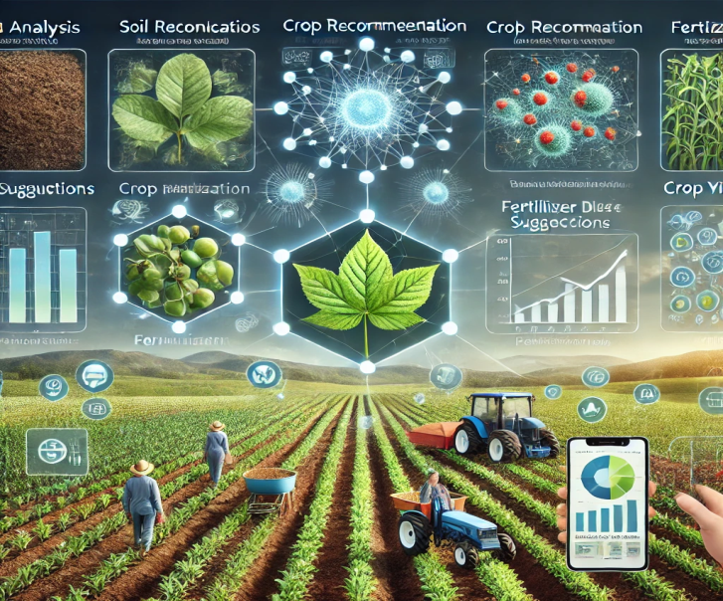
Fig. Smart Farming techniques
The core of the system begins with soil analysis, where a Convolutional Neural Network (CNN) model is utilized to classify soil types based on image inputs. Understanding the soil type allows for precise crop recommendations, further optimized using Random Forest and XGBoost algorithms. This data-driven approach ensures that crops are selected based on the most compatible soil conditions, boosting the likelihood of higher yields. Additionally, a plant disease detection module, also powered by a CNN model based on the MobileNet architecture, enables early identification of common diseases through image uploads of affected leaves. The system provides not only diagnoses but also actionable management strategies, allowing farmers to mitigate disease spread and reduce crop losses.
Beyond disease detection, the system offers tailored fertilizer recommendations that consider plant diseases, ensuring nutrient requirements are met efficiently. Crop yield prediction is another critical feature, implemented through Long Short-Term Memory (LSTM) networks that analyze location and soil parameters to forecast production levels. By integrating these various machine learning models, the system offers a comprehensive solution that addresses multiple facets of modern agriculture, contributing to more inform farming practices and improving overall food security.
Optimizing agriculture through machine learning techniques involves utilizing data-driven approaches to enhance various farming practices. Machine learning algorithms can predict crop yields by analyzing historical data, weather patterns, and soil conditions, enabling farmers to make informed planting decisions. Additionally, these techniques assist in soil analysis by classifying soil types and predicting properties like pH and nutrient content, which helps in selecting suitable crops. Moreover, machine learning aids in pest and disease detection through image analysis, allowing for early interventions to minimize crop loss. By optimizing irrigation management and resource utilization, machine learning fosters precision farming, ultimately leading to increased agricultural productivity and sustainability.

- Objectives:
The Next-Gen Groundwater Models project aims to predict groundwater availability using advanced machine learning techniques. K-means clustering is first applied to the aqua dataset to categorize regions into clusters based on groundwater levels, identifying areas with varying water availability. Two classification models, Random Forest and Deep Convolutional Neural Networks (DCNN), are then utilized to predict water-bearing zones. Random Forest uses an ensemble approach for robust predictions, while DCNN captures intricate patterns in the data to enhance accuracy. The model’s performance is evaluated using metrics like RMSE and MAE, and visualizations such as graphs and charts are generated to illustrate groundwater usage for both domestic and industrial purposes. The system is designed to support informed decision-making by testing and analyzing new data for real-time groundwater prediction.

- Scope
The scope of the Next-Gen Groundwater Models project involves developing a predictive system for groundwater availability by leveraging machine learning techniques. It includes clustering regions using K-means based on groundwater levels, and utilizing Random Forest and Deep CNN models to classify and predict water-bearing zones. The project also encompasses generating visualizations like charts and graphs to represent groundwater usage trends, supporting decision-making for domestic and industrial applications. Additionally, the model's accuracy will be evaluated using RMSE and MAE, ensuring reliable predictions for future groundwater management.

- Methodology
In the proposed method, the methodology comprises three main components:
- Soil Prediction and Crop Recommendation
We start by analyzing soil images to classify soil types using a Convolutional Neural Network (CNN). This model leverages image data to provide accurate soil classification. Based on the identified soil type, we implement Random Forest and XGBoost algorithms to recommend suitable crops that can thrive in specific soil conditions. These algorithms utilize various features, such as soil composition and environmental factors, to optimize crop selection for improved yield.
b) Plant Leaf Disease Detection and Fertilizer Recommendation
A plant disease detection module is integrated, which utilizes a CNN model based on the MobileNet architecture. Farmers can upload images of plant leaves, and the model identifies common diseases, such as blight, rust, and leaf spot. Early detection enables timely intervention, reducing crop loss. For each detected disease, we recommend management strategies and appropriate fertilizers, leveraging the Random Forest and XGBoost algorithms to suggest the best options based on the disease and soil conditions.
c) Crop Yield Prediction
To predict crop yield, we utilize Long Short-Term Memory (LSTM) networks that analyze various parameters, including soil type, weather conditions, and crop history. This model is trained on historical data to understand patterns and forecast future yields accurately. By integrating these predictions with the earlier components, farmers receive comprehensive insights to make informed decisions about crop management and resource allocation.
Upload Soil image dataset
Train CNN Algorithm
Predict soil and recommend plant
Upload leaf disease dataset
Train CNN algorithm
Disease classification
LR for crop yield

Predict yield

- System architecture:

5.1 Algorithms
❖ Convolutional Neural Network (CNN):
Used for soil prediction by analyzing soil images. The CNN model classifies soil types based on image data, helping in selecting the best crops for that particular soil type.
❖ Random Forest and XGBoost:
These ensemble learning methods are used for crop recommendation and fertilizer suggestion. After soil classification, Random Forest and XGBoost analyze soil characteristics and environmental factors to recommend suitable crops. They are also used to suggest fertilizers based on plant disease data.
❖ MobileNet-based CNN:
This is used in plant disease detection. Farmers upload images of plant leaves, and this CNN model identifies common plant diseases like blight, rust, and leaf spots, enabling early intervention to reduce crop loss.
❖ Long Short-Term Memory (LSTM):
LSTM networks are employed for crop yield prediction by analyzing historical data, soil parameters, and environmental factors. The model predicts future yields, assisting farmers in planning crop cycles and maximizing productivity.
❖ K-Nearest Neighbor (KNN):
Used for analyzing new data inputs for soil or crop classification based on historical data. KNN helps in identifying nearest matches for new crop data, aiding in decision-making.
❖ Support Vector Machine (SVM):
Used for classification of crops and plant diseases. SVM creates decision boundaries between different crop types or disease states, improving the accuracy of detection and recommendation systems.
5.2 Dataset:
For the dataset used in Optimizing Agriculture Using Machine Learning, the soil image dataset consists of 1281 images, processed using feature extraction algorithms. The number of features before applying the extraction was 12,288, and after feature extraction, 1200 key features were identified. The system leverages this processed data for tasks like soil prediction, crop recommendation, plant disease detection, and crop yield prediction.

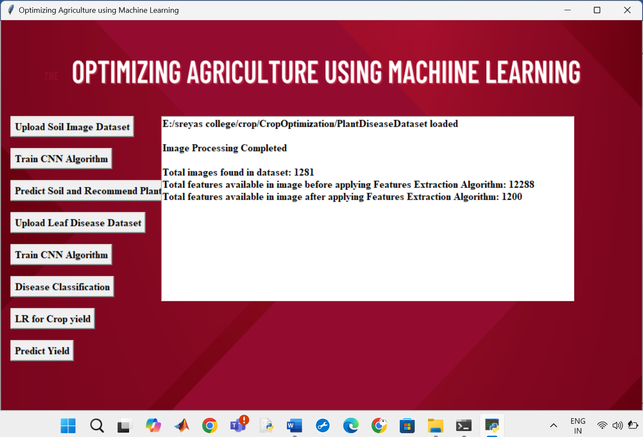

5.3 Data processing
For Optimizing Agriculture Using Machine Learning Techniques, the data processing begins by importing datasets using the read_csv() function to read CSV files. The Pandas package is used, specifically the iloc[] method, to extract independent and dependent variables from the dataset. This phase involves cleaning and transforming raw agricultural data into a format suitable for machine learning models. It is crucial for building effective models like CNN for soil prediction, Random Forest for crop recommendation, and MobileNet-based CNN for plant disease detection. The data preparation ensures the system can accurately process soil, crop, and disease data for optimal results. Following this, various algorithms, such as CNN, Random Forest, XGBoost, and LSTM, are used across different tasks like crop recommendation, disease detection, and yield prediction. Time complexities of these algorithms are also evaluated to determine the most efficient algorithm for large-scale agricultural datasets.

5.4 Results

In proposed method we used
- Soil prediction and crop recommendation
- Plant leaf disease detection and fertilizer recommendation
- Crop yield prediction

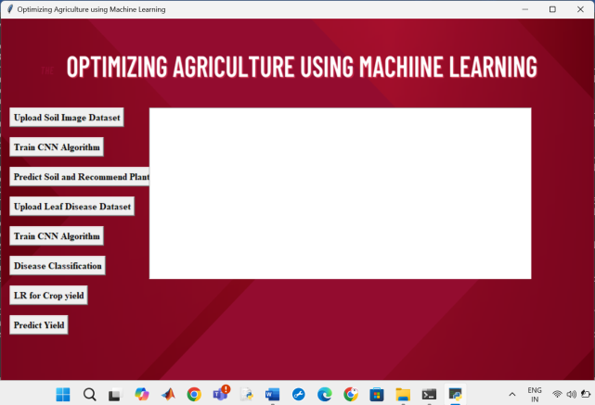

Fig. GUI for proposed Method

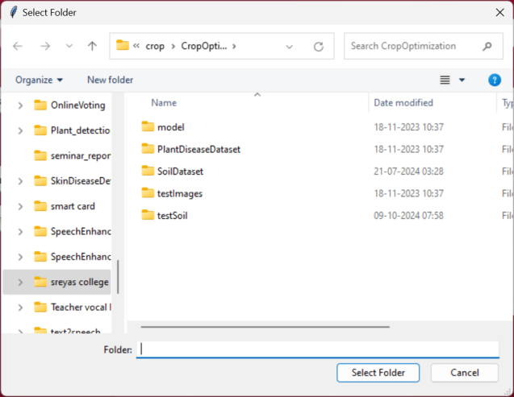
Fig. Upload the dataset related to soil
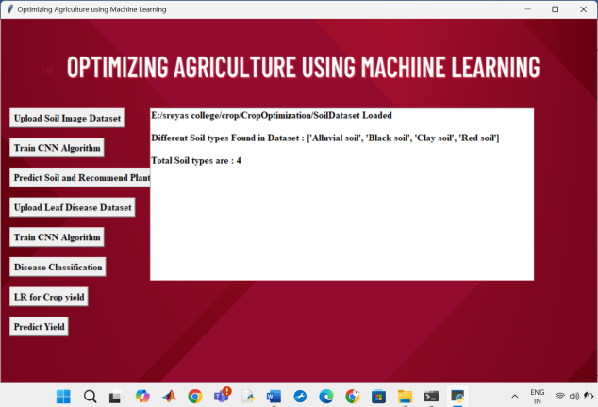
Fig. After uploading the soil dataset , details are shown
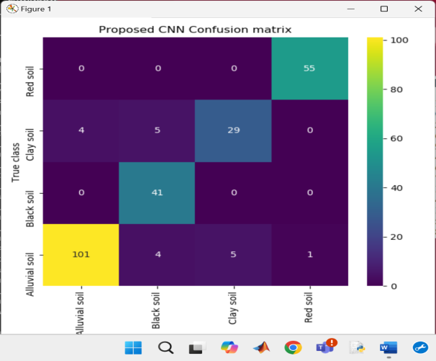
Fig. Confusion matrix for soil classification and plant recommendation

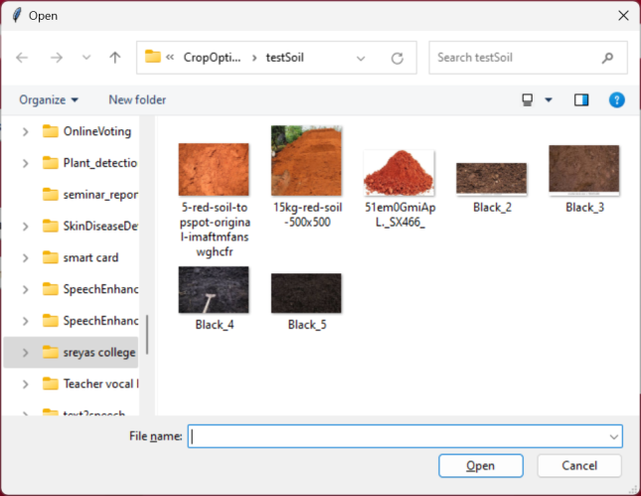
Fig. select soil image for testing

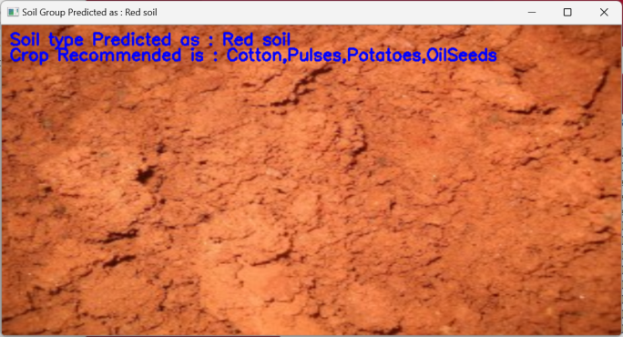
Fig. soil predicted and crop recommended

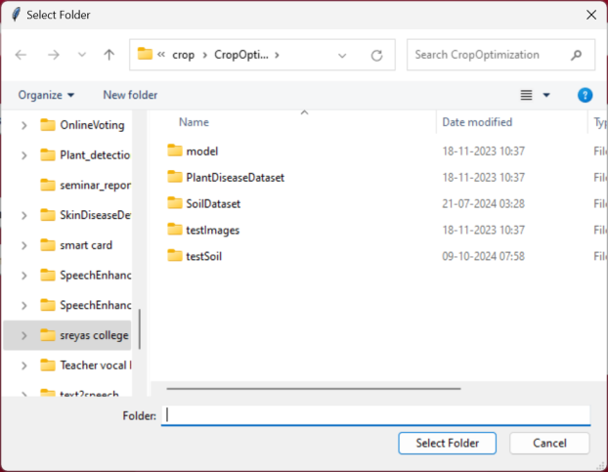

Fig. Uploading leaf disease dataset

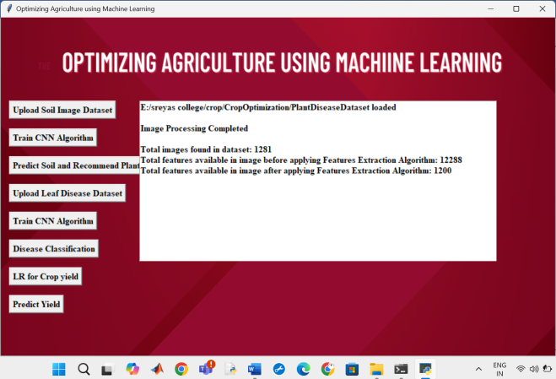
Fig. after uploading details are shown

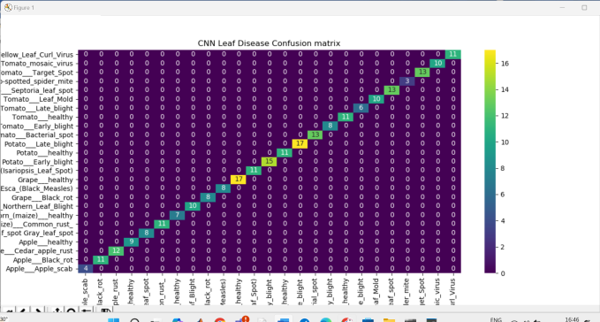
Fig. Confusion Matrix for plant disease detection and fertilizer recommendation

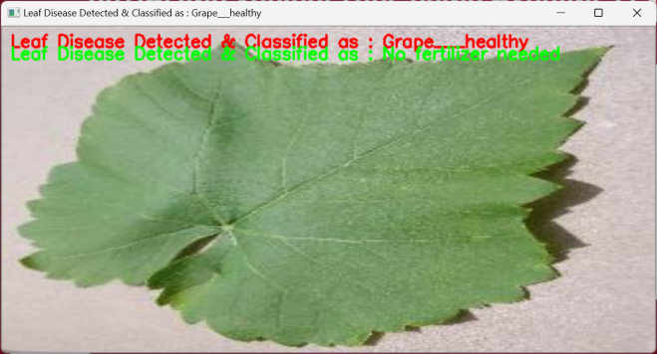
Normal leaf without disease

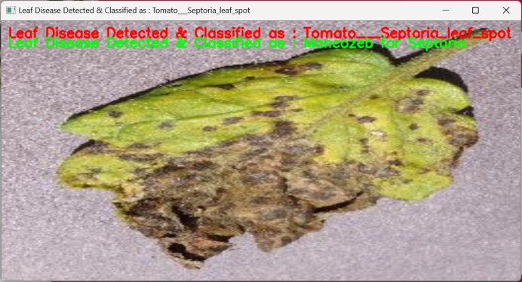
Fig. disease is predicted and fertilizer is recommended

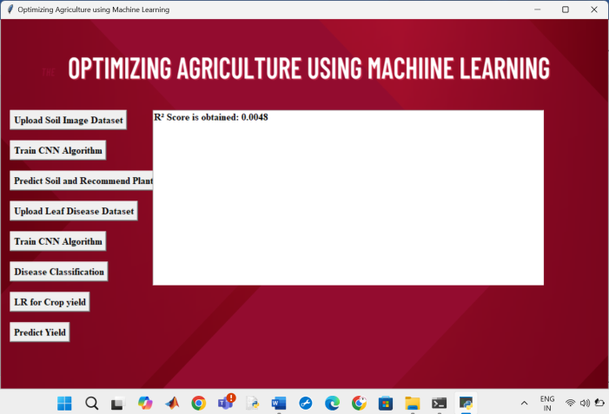
Fig. Linear regression R2 score is shown

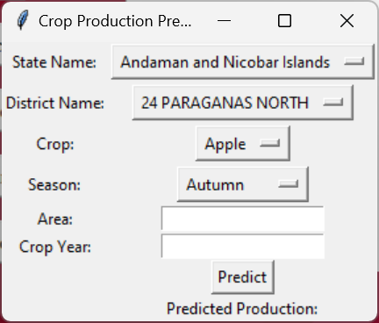
Fig. crop yield prediction interface

Conclusion
In conclusion, the paper demonstrates the transformative potential of AI-driven solutions in the agricultural sector. By leveraging machine learning models such as CNN for soil classification, Random Forest and XGBoost for crop recommendation and fertilizer suggestions, MobileNet-based CNN for plant disease detection, and LSTM for crop yield prediction, the system provides a comprehensive tool to assist farmers. This integrated approach supports sustainable farming practices, optimizes resource use, and enhances decision-making to improve crop productivity and reduce losses. Overall, this project highlights how machine learning can address key challenges in agriculture, contributing to increased productivity and global food security.

REFERENCES
- Li, Lili, Shujuan Zhang, and Bin Wang. "Plant disease detection and classification by deep learning—a review." IEEE Access 9 (2021): 56683-56698.
- Applalanaidu, Majji V., and G. Kumaravelan. "A review of machine learning approaches in plant leaf disease detection and classification." In 2021 Third International Conference on Intelligent Communication Technologies and Virtual Mobile Networks (ICICV), pp. 716-724. IEEE, 2021.
- Rahman, Sk Al Zaminur, Kaushik Chandra Mitra, and SM Mohidul Islam. "Soil classification using machine learning methods and crop suggestion based on soil series." In 2018 21st International Conference of Computer and Information Technology (ICCIT), pp. 1-4. IEEE, 2018.
- Mali, Y. ., Rathod, V. U. ., Kulkarni, M. M. S. ., Mokal, P. ., Patil, S. ., Dhamdhere, V. ., & Birari, D. R. . (2023). A Comparative Analysis of Machine Learning Models for Soil Health Prediction and Crop Selection. International Journal of Intelligent Systems and Applications in Engineering, 11(10s), 811–828. Retrieved from https://ijisae.org/index.php/IJISAE/article/view/3335
- D. J. Reddy and M. R. Kumar, "Crop Yield Prediction using Machine Learning Algorithm," 2021 5th International Conference on Intelligent Computing and Control Systems (ICICCS), Madurai, India, 2021, pp. 1466-1470, doi: 10.1109/ICICCS51141.2021.9432236.
- Kamilaris, A., & Prenafeta-Boldú, F. X. (2018). "Deep Learning in Agriculture: A Survey." Computers and Electronics in Agriculture, 147, 70-90. DOI: 10.1016/j.compag.2018.02.016.
- Zhang, C., & Wang, J. (2020). "Application of Machine Learning in Precision Agriculture: A Review." Agricultural Systems, 179, 102785. DOI: 10.1016/j.agsy.2019.102785.
- Whelan, B., & Hakeem, A. (2019). "Machine Learning for Smart Agriculture: A Review." Applied Sciences, 9(19), 3937. DOI: 10.3390/app9193937.
- Mohanty, S. P., Patil, A. S., & Barik, S. K. (2021). "A Comprehensive Review on Applications of Machine Learning in Agriculture." Artificial Intelligence in Agriculture, 4, 215-227. DOI: 10.1016/j.aiia.2021.08.001.
- Liu, Y., Zhang, L., & Liu, Z. (2020). "Machine Learning in Agriculture: A Comprehensive Review." Information Processing in Agriculture, 7(1), 1-19. DOI: 10.1016/j.inpa.2019.09.002.

